Interactive Digital Art & Design

final year project – Missed In The mist

Enya Conroy C00257920

06/09/2024

Contents

Acknowledgements 2

Project Abstract 2

Project Introduction 2

Requirements analysis 3

Research 4

Art Style 4

Project Description 5

Project Milestones 8

Project Review & Conclusions 8

References 10

# Acknowledgements

I would like to extend thanks to the number of people who helped me throughout this project and made its completion possible. These include:

* My lecturers in SETU, particularly Anita Dice and Colm O Neill, for their continued support and motivation as they continued to take time from their schedules to answer any questions or doubts I had.
* My classmates, particularly Adam Kane and Abeer Abou Hajar, for their willingness to share their knowledge as well as personal encouragement when I hit any obstacles within the project.
* Anyone who may have directly or indirectly had an impact on the inspiration or completion of this project.

Without the support of these people this project would have been innumerably more difficult so I’d like to express my gratitude to every one involved.

# Project Abstract

"Missed in the Mist" is a digital interactive storybook developed as part of my final year project for the Interactive Digital Art & Design program at SETU. It utilizes a tool called “scrolly-telling”, this is the process of creating a webpage which has interactions / animations intertwined with the pages content. The narrative follows a ghost wandering through a misty forest, initially weighed down by darkness but gradually discovering small moments of joy, symbolizing a shift from focusing on the negative to appreciating life’s simple pleasures. I hope this project can provide reassurance or encouragement to anyone facing adversity.

# Project Introduction

The name “Missed in the Mist” is a play on words in reference to getting too weighed down in negativity to see the positive side of things. This story contains themes that everyone can relate to in a simple short story.

The story starts with our ghost entering the forest as he does every day, both physically and mentally. He’s bored and tired and angry. Only this time he decides to take a different path, a different way of doing things, a different mindset. Along the way he sees several scenes – some good, some bad, some neither. You witness his view of things change and lighten and I hope that the reader can take a page out of this book. These scenes are created using “scrolly-telling” so the animations are triggered once the user has scrolled to a certain point within the page. These “trigger points” only happen after the users input, further lending to the idea that they are in control of the story, and hopefully their own story.

I was heavily inspired to complete this project during a conversation I was having with friends. We were light heartedly joking about challenges we’d faced or things we’d gone through when we took a step back and realized we’d had some pretty big life altering things happen to us. All before the age of 21. Whether that be change, loss, sickness, or anything in between. That’s when the age old phrase “If you don’t laugh, you’ll cry” was mentioned. I realized you really do have two choices. Take the things you’ve been through personally, become bitter and dejected *or* realize everyone’s been through their own challenges and keep smiling; maybe even crack a joke or two.

# Requirements analysis

My project successfully encompasses what I have learned during my time studying Interactive Digital Art and Design at SETU. The 3 core elements of the course were all utilized in the creation of this project.

**Art:** All of the images used to create the animations as well as the opening and closing screens were made by me. Each scene was composed of 3 separate images which I hand drew using Procreate. The opening and closing screens were created using a combination of Procreate, Figma and Canva.

**Design:** The design skills accumulated from college came into play when deciding on an appropriate font to use for my text. Formatting also needed to be considered when deciding on its position on the page, so as to make sure it is legible to the user but doesn’t obscure the artwork. The storyline and illustrations should compliment each other not compete.

**Programming:** The page itself is created using a combination of HTML, CSS, and JavaScript. In order to implement the “scrolly-telling” features I also had to use a JavaScript library called “Scrolllama”, while I had never used this specific library before I did learn the key skills needed in order to research, understand and use a new library while in college.

# Research

In order to get a good idea of how stories can be told in a successful and engaging way online I decided to look into articles which had been written using “scrolly-telling” as well as a number of web-comics.

A lot of the articles I viewed were very text heavy upon first glance however on interacting with the page the secondary visuals were triggered and successfully complimented the rest of the content – this engages the user and helps to support the points being made with an interactive visual aid. During my research I came across a tool called Shorthand which is a platform used to create “scrolly-telling” web pages. This provided me with many examples and also a means of prototyping my project before I began development.

The web-comics I looked at were more focused on the visuals and used smaller bits of text to clarify things that were happening in the scene. Web-comic artists implement clever practices to get the most out of their 2D canvas. Things like extending images over multiple screens to show height / depth, or having similar images in sequence to show movement. These are used to draw the user in and create an engaging story.

After investigating both mediums I felt confident that I had learned what was needed to create a fun and functional digital storybook.

# Art Style

I wanted my chosen art style to be both dark and moody but also simple and easy to digest. The artwork had to portray the glum feeling our main character was experiencing as well as the overall dark atmosphere you would find in a misty forest. I chose to use a muted colour palette of dark greens, greys and browns for the majority of my images. This was to help keep the artwork cohesive but also to put across the mood to the readers. As the story progresses I introduced scenes with brighter colours (pinks, blues, etc) as well as scenes with glowing objects intertwined, such as moon beams, glow bugs, or bioluminescent mushrooms to literally symbolize finding light within the dark. I kept the linework simple and straightforward and opted to use silhouettes in some scenes, partly to go with the themes of darkness and partly so as to not distract the reader from the overall message. I think the visual style helps lend itself to the accessibility of the story as the message is one that a lot of people can relate to.

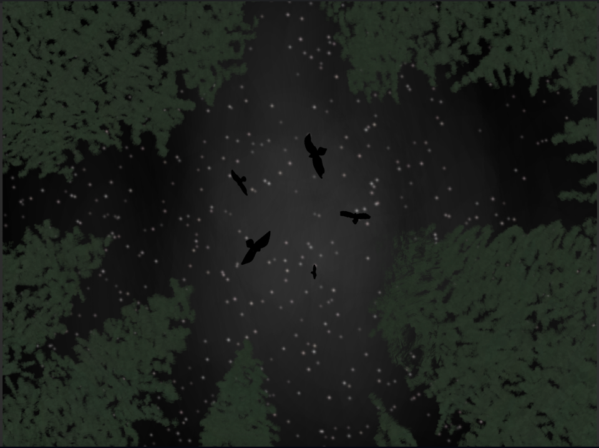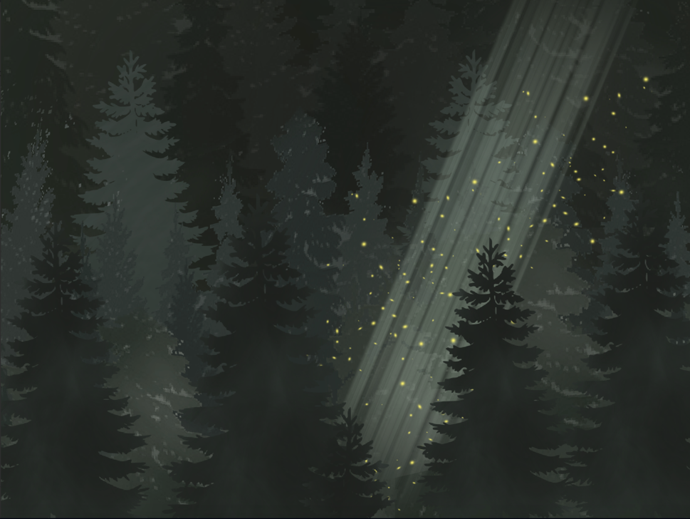

# Project Description

The output of my completed project is an interactive digital storybook that the user navigates by scrolling down through the page to reveal the next scene and trigger the image and text animations. On opening the project the user is shown a title screen which displays the name of the project, “Missed in the Mist”, accompanied by an illustration of a forest below a night sky. This immediately sets the scene for the reader.

There is a mute / unmute button in the top right corner which can be used to toggle background music on or off. I chose the music as I felt it suited the dark and whimsical atmosphere of the art but was soft enough to be comforting as the tone of the story changes. I chose to make the button a small icon on a transparent background as I didn’t want it to distract from the story or art however I did want to give users an option and avoid auto-playing as this can be frustrating for users if it is unexpected.

Once the user begins scrolling and the top of the next scene is ¾ of the way up the viewport (as I had set the offset to 0.75) the animations will begin to play. This is done by overlaying 3 slightly altered images of the same scene on top of each other, changing their opacity accordingly and then cycling through them to give the impression of movement.

The text for each scene is also animated. Each section of the story rises upwards on the screen and increases in opacity until settling in place and becoming an off-white colour. This is done to give users time to slow down and read the text while also making the scene more dynamic. I chose the font “Chanticleer Roman” as it was reminiscent of old fairytale story books to me. I went with an off-white colour to give good contrast to the darker artwork featured behind while being less straining on the eyes than a stark white.

When the user moves on to the next scene the interval is cleared and the previous steps repeat for this new scene – the text begins to animate and the images begin to cycle. This process is followed for all 7 scenes as the ghost makes his way through the forest, and when he finally leaves with a refreshed perspective.

The entire page also contains an overlay of fog to add dimension to the story and further immerse the reader while also adding to the set atmosphere.

The final scene is a closing screen featuring the night sky and forest overview once again with a simple “The End” to signify the completion of the story and my project with a small detail containing my name in the bottom right hand corner.

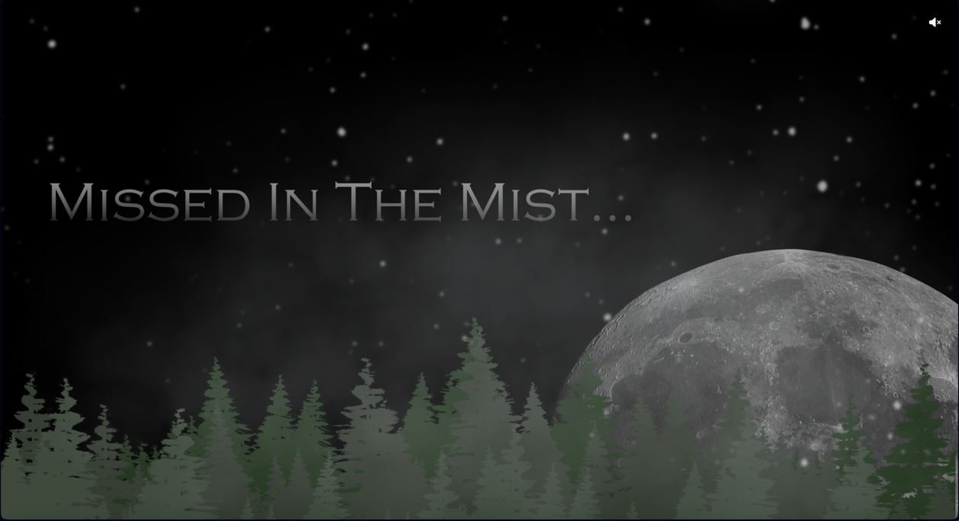

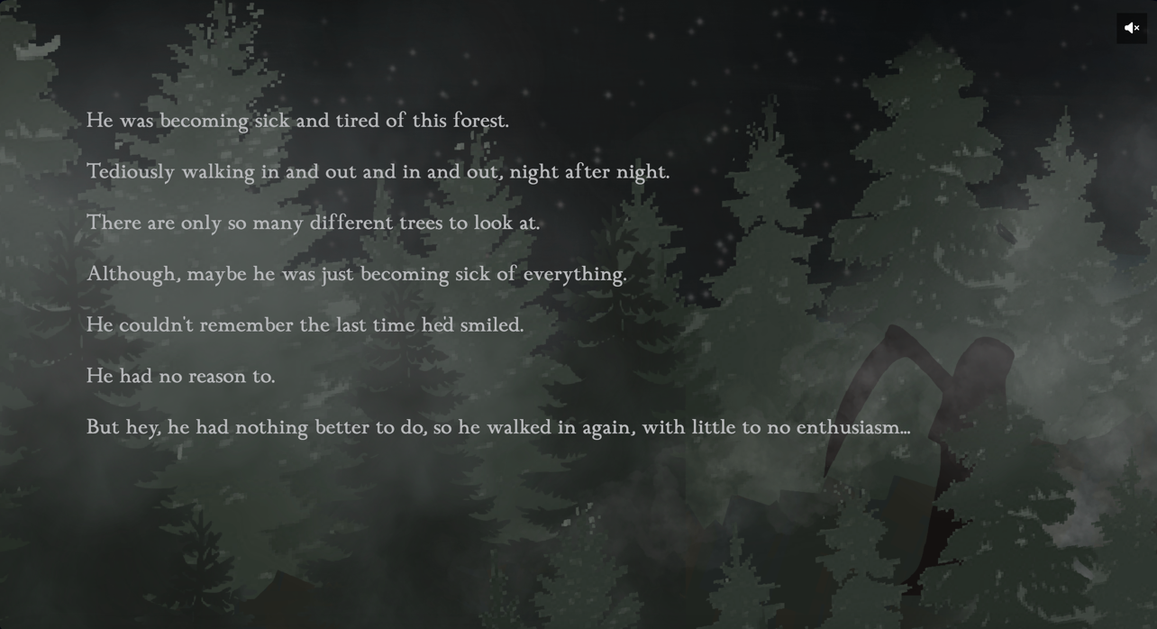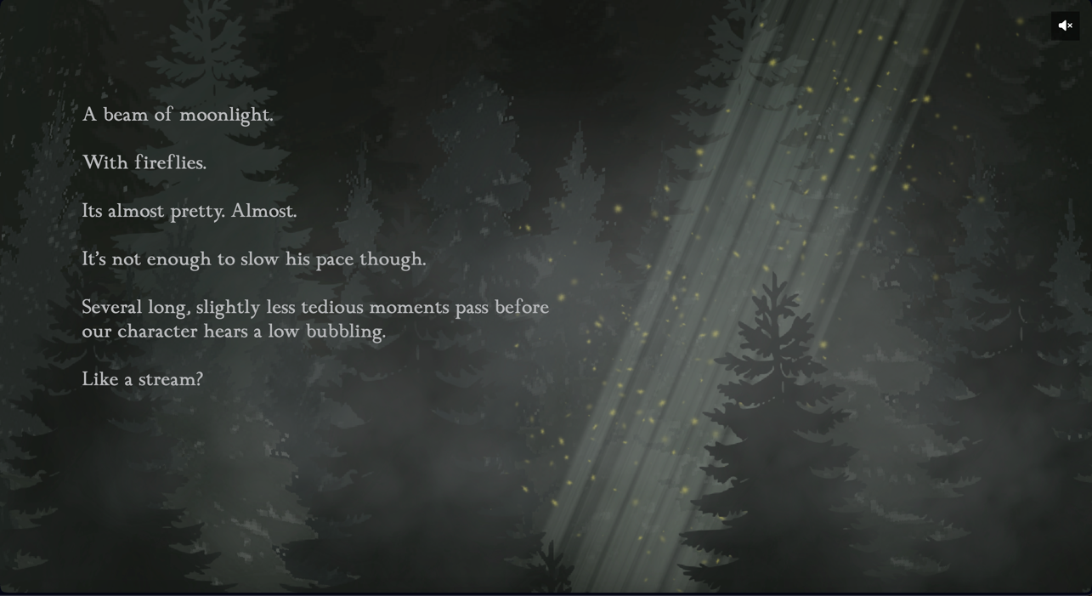

# Project Milestones

**Start:** I started production on this project at the beginning of my 4th year, in September 2023. The first couple of months were spent brainstorming my idea, speaking to my project supervisor, planning my steps, making concept art, doing research and investigating my chosen fields.

**Christmas mid-point check:** By the check-in point I had completed my storyline and had began working on my artwork. I had begun using Shorthand to construct my project but it was decided that the project should be created using HTML.

**End of semester:** By the end of the semester I had finished all artwork but fallen behind on my scheduled plan for the project. I was also facing challenges when it came to the programming side of my project as well as in my personal life. This led to me making the decision to defer my project.

**Summer:** Over the summer months I continued to work on my project alongside my job and made progress in the areas I was struggling. I further researched the “scrollama” library and looked at videos online of people that had used it previously. I also had some developers from work lend a hand in explaining some of the functionality that I had not understood previously. This allowed me to finish the project and begin on the report.

**Present:** Both project and report completed.

# Project Review & Conclusions

Overall I was very happy with how my project turned out. My chosen area gave me the opportunity to explore and work with new ideas, tools and ways of working. I was able to build on some of the skills I had learned during my time on the course such as digital art, website design and programming. My efficiency with tools I previously used such as Procreate, VS Code, and Git massively improved throughout my time working on the project and I look forward to seeing them improve more over time. I also had the chance to learn new skills along the way such as utilizing JavaScript libraries and even smaller achievements like incorporating FontAwesome to directly insert icons into my webpage.

I did face some challenges along the way such both personally and professionally however I think this lends itself to the motto of the story. If I was to start this project again I would be better suited to tackle these issues. By simplifying my animations I was able to create an effective visual display for my storyline however given more time I would love to add some more diversity to the types of animations used, for example creating more dynamic images that span a larger screen space and interact with each other vertically as opposed to being stacked on one another. I also had unresolved issues regarding backwords scrolling as my text animations didn’t reset correctly when a scene was exited. This is something I would love to rectify.

In conclusion I believe my project successfully showcases what I have learned during my time at SETU and despite challenges achieves its goal of being an easy to enjoy and uplifting story.

# References

Osman, M. (2024, September 6). *The web designer’s guide to scrollytelling*. Retrieved from WIX: https://www.wix.com/studio/blog/scrollytelling

Shorthand. (2024, September 6). Retrieved from Shorthand: https://shorthand.com

TV Tropes. (2024, September 6). *Popular Webcomic Sites*. Retrieved from Tv Tropes: https://tvtropes.org/pmwiki/pmwiki.php/Main/PopularWebcomicSites